Question 1. Shannon's Theorem
Shannon's Theorem gives an upper bound to the capacity of a link, in bits per second (bps), as a function of the available bandwidth and the signal-to-noise ratio of the link.
The Theorem can be stated as:

C = B * log2(1+ S/N)
where C is the achievable channel capacity, B is the bandwidth of the line, S is the average signal power and N is the average noise power.
The signal-to-noise ratio (S/N) is usually expressed in decibels (dB) given by the formula:

10 * log10(S/N)
so for example a signal-to-noise ratio of 1000 is commonly expressed as

10 * log10(1000) = 30 dB.
Here is a graph showing the relationship between C/B and S/N (in dB):

Examples
Here are two examples of the use of Shannon's Theorem.

Modem
For a typical telephone line with a signal-to-noise ratio of 30dB and an audio bandwidth of 3kHz, we get a maximum data rate of:

C = 3000 * log2(1001)
which is a little less than 30 kbps.

Satellite TV Channel
For a satellite TV channel with a signal-to noise ratio of 20 dB and a video bandwidth of 10MHz, we get a maximum data rate of:

C=10000000 * log2(101)
which is about 66 Mbps.

Question 2. An upper-layer packet is split into 10 frames, each of which has an 80 percent chance of arriving undamaged. If no error control is done by the data link protocol, how many times must the message be sent on average to get the entire thing through?

Solution:
Since each frame has a chance of 0.8 of getting through, the chance of the whole message getting through is (0.8)¹⁰, which is about 0.107. Call this value p. The expected number of transmissions for an entire message is then
∞ ∞
E = ∑ ip(1-p)^{i-1} = p∑ i(1-p)^{i-1}
i=1 i=1

To reduce this, use the well known formula for the sum of an infinite geometric series, ∞
S = ∑ a^{i} = 1
i=1 ------
1 – a
Differentiate both sides with respect to a to get,
∞
S' = ∑ ia^{i-1} = 1
i=1 -------
(1-a)²

Now use a = 1-p to get E = 1/p. Thus, it takes an average of 1/0.107, or about 9.3 transmissions.

Variation of problem 1)
Now do error detection on each frame separately. If a frame contains
an error, it must be retransmitted (until it has arrived intact).
Once every frame has arrived intact once, the message has arrived.
How many frames (in average) are transmitted before the message has
arrived intact?

Solution:

Probability that each frame arrives intact: 0.8

Average for a single frame to arrive intact is: 1/0.8 = 1.25.

For 10 frames to arrive intact, the average is 1.25 * 10 = 12.5.

Hence, the number of frames need to be transmitted before the message arrives intact is 12.5.

OR
Ans. 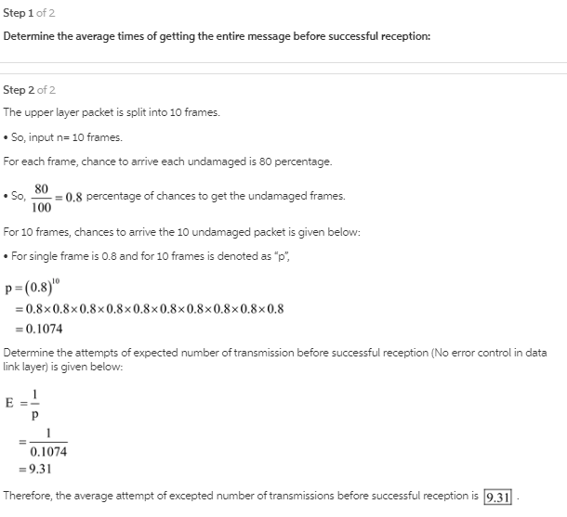
Question 3. 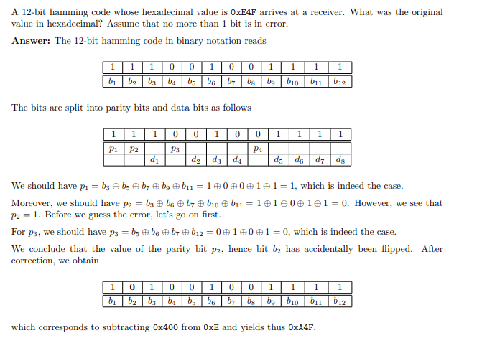
OR
Ans: The original codeword set by the sender is 0xA4F. The data bit delivered to the upper layer of the receiver is 10101111. The detail of decoding process is shown below.
1 | 2 | 3 | 4 | 5 | 6 | 7 | 8 | 9 | 10 | 11 | 12 | Bit position
C0 | C1 | D1 | C2 | D2 | D3 | D4 | C3 | D5 | D6 | D7 | D8 | codeword pattern
 |  |  | E |  |  |  | 4 |  |  |  | F | receive bit patter in hexadecimal
1 | 1 | 1 | 0 | 0 | 1 | 0 | 0 | 1 | 1 | 1 | 1 | receives bit pattern
 |  | 1 |  | 0 | 1 | 0 |  | 1 | 1 | 1 | 1 | set aside received check bits
1 | 1 | � |  |  |  |  |  |  |  |  |  | D1 contributes check bit pattern 11 (bit position 3)
 | 1 |  | 1 |  | � |  |  |  |  |  |  | D2 contributes check bit pattern 110 (bit position 6)
1 |  |  |  |  |  |  | 1 | � |  |  |  | D5 contributes check bit pattern 1001 (bit position 9)
 | 1 |  |  |  |  |  | 1 |  | � |  |  | D6 contributes check bit pattern 1010 (bit position 10)
1 | 1 |  |  |  |  |  | 1 |  |  | � |  | D7 contributes check bit pattern 1011 (bit position 11)
 |  |  | 1 |  |  |  | 1 |  |  |  | � | D7 contributes check bit pattern 1100 (bit position 12)
1 | 0 |  | 0 |  |  |  | 0 |  |  |  |  | Calculate check bit using even parity bit
 | X |  |  |  |  |  |  |  |  |  |  | positions sent and rcvd check bit not the same
 | 2 |  |  |  |  |  |  |  |  |  |  | sum of position weight=2 position 2 is garbled
 | 0 |  |  |  |  |  |  |  |  |  |  | correct the bit.
1 | 0 | 1 | 0 | 0 | 1 | 0 | 0 | 1 | 1 | 1 | 1 | correct codeword
 |  |  | A |  |  |  | 4 |  |  |  | F | original codeword sent in hexadecimal.
 |  | 1 |  | 0 | 1 | 0 |  | 1 | 1 | 1 | 1 | Data bits delivered to upper layer
- What was the original codeword sent by the sender in hexadecimal? Assume that not more than I bit is in error.
Ans:
1 | 0 | 1 | 0 | 0 | 1 | 0 | 0 | 1 | 1 | 1 | 1

Question 4. A message 1001 1100 1010 0011 is transmitted using the Internet Checksum (using 4-bit words).
What is the value of the checksum?
Answer: Adding the 4-bit words yields 1001 + 1100 + 1010 + 0011 = 100010. The carry is added to the
LSBs: 0100. The one’s complement value is then 1011, which is the checksum.
And indeed, the check works out as expected. Adding the data and the checksum yields 1001 + 1100 +
1010 + 0011 + 1011 = 101101, which gives 1111 (carry) and thus 0000 (negation).
Question 5. A channel has a bit rate of 4 kbps and one-way propagation delay of 20 ms. The channel uses stop and wait protocol. The transmission time of the acknowledgement frame is negligible. To get a channel efficiency of at least 50%, the minimum frame size should be
(A) 80 bytes
(B) 80 bits
(C) 160 bytes
(D) 160 bits
Answer: (D)
Explanation:
Bit rate = 4 kbps
One-way propagation delay = 20 ms
Efficiency = Transmission time of packet/(Transmission time of packet + 2 * Propagation delay)
0.5 = x/(x + 2 * 20 * 10⁻³)
x = 20 * 10⁻³
x = 40 * 10⁻³
Minimum frame size / Bit rate = 40 * 10⁻³
Therefore, Minimum frame size = 40 * 10⁻³ * 4 * 10³ = 160 bits
Thus, option (D) is correct.

Question 6. What is the baud rate of the standard 10-Mbps 802.3 LAN?
The Ethernet uses Manchester encoding, which means it has two signal periods per bit sent. The data rate of the standard Ethernet is 10 Mbps, so the baud rate is twice that, or 20 megabaud.
OR
Question 6. 1. What is the baud rate of classic 10-Mbps Ethernet?
Ans:-
The Ethernet mainly uses Manchester encoding, that means it has two signal periods per bit that is sent. Data rate of the Ethernet = 10 Mbps Baud rate = 2 * data rate = 20 Megabaud.
Question 7. Sketch the Manchester encoding on a classic Ethernet for the bit stream 0001110101.
Answer: Manchester encoding is used in Ethernet for Synchronization. The Manchester encoding for the bit stream 0001110101:
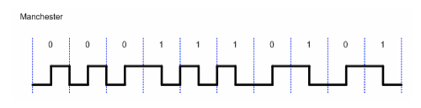

OR

Why does Ethernet use Manchester encoding? Sketch the Manchester encoding for the bit stream: 0001110101. Sketch the differential Manchester encoding for the same bit stream.
Ethernet uses Manchester encoding for two reasons. First, binary encoding does not differentiate between a 0 bit (0 volt) and an idle sensor (also 0 volts). Manchester encoding in Ethernet systems use +0.85 volts for a high signal and -0.85 volts for a low signal. Second, by using Manchester encoding, the receiver can determine the start, middle, and end of each bit without referencing some external clock. A high-to-low or low-to-high transition is used for every bit so that the receiver can synchronize with the sender at any time.
- Manchester: low-high|low-high|low-high|high-low|high-low|high-low|low-high|high-low|low-high|high-low|
- Diff Manchester: l-h|l-h|l-h|h-l|l-h|h-l|h-l|l-h|l-h|h-l|

Question 8. 1000-byte-large data blocks are sent over a fiber line with a distance of 10000km using the sliding window protocol. Link bandwidth is 2Gbps and propagation speed on the fiber is s = 2/3 c. Here, c is speed of light which is approximately 3 · 108m/s.
(a) What should the size of the send window be to keep the pipe full? State your assumptions if you make any.
(b) Does it make sense to have a larger window size than what is calculated in part a)?

Question 9.

Question 10. A 1Mbps satellite link connects two ground stations. The altitude of the satellite is 36,504 km and speed of the signal is 3 × 10⁸ m/s. What should be the packet size for a channel utilization of 25% for a satellite link using go-back-127 sliding window protocol? Assume that the acknowledgment packets are negligible in size and that there are no errors during communication.
(A) 120 bytes
(B) 60 bytes
(C) 240 bytes
(D) 90 bytes
Answer: (A)
Explanation: According to given data,
Transmission time (Tx) = distance / speed,
Propagation time (Tp) = size of packet / bandwidth,
a = Tp / Tx
Now, efficiency is,
efficiency = window size / (1 + 2a)
→ 0.25 = 127 / (1 + 2((36504*10³ / (3*10⁸)) / size of packet / 1*10⁶))
→ 0.25 = (127*size of packet) / (L + 0.48*10⁶)
→ 0.25*(size of packet) + 0.25*0.48*10⁶ = 127*(size of packet)
→ size of packet = 960 bits
→ size of packet = 120 bytes
So, option (A) is correct.

OR

Time to reach satellite = 36504000/3×10⁸ = 0.121685
RTT = 4×Time to reach satellite (S1→S, S→S2, S2→S, S→S1)
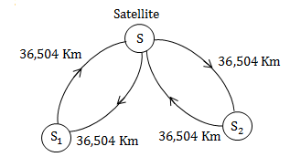
∴ RTT = 0.48
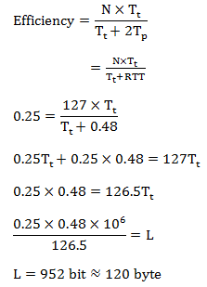

OR
A 1 Mbps satellite link connects two ground stations. The altitude of the satellite is 36504 km and speed of the signal is 3 x 10⁸ m/sec. What should be the packet size for a channel utilization of 25% for a satellite link using go back 127 sliding window protocol?
- 120 bytes
- 60 bytes
- 240 bytes
- 90 bytes

Solution-

Given-
- Bandwidth = 1 Mbps
- Distance = 2 x 36504 km = 73008 km
- Propagation speed = 3 x 10⁸ m/sec
- Efficiency = 25% = 1/4
- Go back N is used where N = 127

Let the packet size be L bits.

Calculating Transmission Delay-

Transmission delay (T_{t})
= Packet size / Bandwidth
= L bits / 1 Mbps
= L μsec

Calculating Propagation Delay-

Propagation delay (T_{p})
= Distance / Speed
= (73008 x 10³ m) / (3 x 10⁸ m/sec)
= 24336 x 10⁻⁵ sec
= 243360 μsec

Calculating Value of ‘a’-

a = T_{p} / T_{t}
a = 243360 μsec / L μsec
a = 243360 / L

Calculating Packet Size-

Efficiency (η) = N / (1+2a)
Substituting the values, we get-
1/4 = 127 / (1 + 2 x 243360 / L)
1/4 = 127 x L / (L + 486720)
L + 486720 = 508 x L
507 x L = 486720
L = 960

From here, packet size = 960 bits or 120 bytes.
Thus, Correct Option is (A).

Question 13. Suppose that the ALOHA protocol is used to share a 56 kbps satellite channel. Suppose that frames are 1000 bits long. Find the maximum throughput of the system in frames/second.
Solution:
Maximum throughput for ALOHA = 0.184
Maximum throughput in frames/sec = (56000 bits/sec) x (1 frame/1000 bits) x 0.184 = 10.304
The maximum throughput is approximately 10 frames/sec.

